****Hundreds of fraudulent votes were discovered. Then a fat green parrot was elected.**

*Kakapo claims victory in New Zealand's Bird of the Year contest*

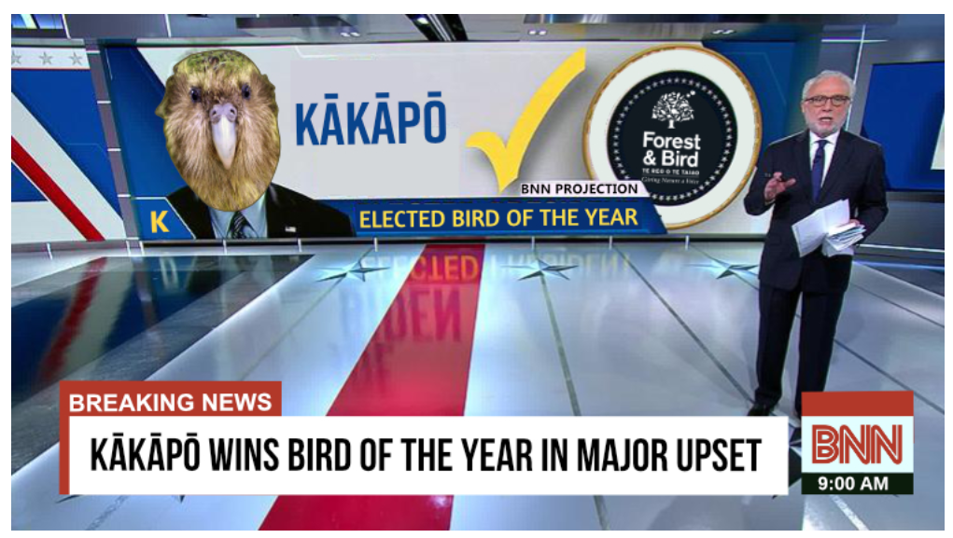

By Jennifer Hassan  
November 16, 2020 at 1:10 p.m.

A plump, waddling parrot has soared past its competition to claim victory in New Zealand’s Bird of the Year contest, a tense race marked by attempted voter interference during a divisive month of campaigning.

In what event organizers conceded was “a stunning upset,” the critically endangered kakapo flew into first place to steal the title — ruffling the feathers of those who say the bright-green parrot unfairly secured a second term as chosen bird.

The bird-of-the-year controversy took flight after data analysts working with Forest & Bird discovered that roughly 1,500 fraudulent votes had been cast.

The “illegal votes,” which were submitted using a suspicious email account and came from the same IP address in Auckland, briefly pushed the country’s tiny kiwi pukupuku bird into the lead, a brazen meddling attempt that sent officials and campaign managers into a flap. Those votes were immediately disregarded, organizers said.

“It’s lucky we spotted this little kiwi trying to sneak in an extra 1500 votes under the cover of darkness!” Laura Keown, spokesperson for Bird of the Year, said in a statement Nov. 10, adding that officials did not “want to see any more cheating.”

Emma Rawson, the kiwi pukupuku campaign manager, said “voter fraud is not the kiwi way” and urged people to uphold the bird’s values of “democracy, fairness, equality and honesty.” The kiwi is symbolic among the people of New Zealand and has been adopted as a national emblem.

Officials urged voters to play by the rules and only vote once per email. “Be warned, we will find you, and we will be disappointed!” a statement on the competition’s official website read in a bid to deter meddling ahead of the polls closing Sunday.

New Zealand’s Antipodean albatross, also known as the toroa, was the favorite to win, leading polls in recent weeks. That was until the kakapo overtook it in the race’s final moments.

The Twitter account representing the toroa accepted the result in humble fashion, declaring: “We conceded with the knowledge that the election was based on preferential voting.” The toroa was already preparing to take the crown in 2021, the bird account tweeted.

No evidence of Russian interference in New Zealand’s ‘Bird of the Year’ contest

Held every year since 2005, the Bird of the Year contest is no stranger to allegations of voter misconduct. In 2019, officials were forced to defend claims that Russians were unfairly attempting to interfere with the outcome after hundreds of international votes were registered.

In 2018, it emerged that one person had cast an estimated 3,000 votes for New Zealand’s rare shag species. The fraudster’s attempt to overthrow the competition came just one year after fake email addresses were set up by cunning voters attempting to sway the vote in favor of the white-faced heron, according to Radio New Zealand.

In recent weeks, local media reported that birds attempting to extend their fan base had flocked to Twitter, Tinder and TikTok in a bid to win votes. Typically, the competition generates around 40,000 votes across a scoreboard of more than 70 entrants.

More than 55,000 votes were cast in the contest that anointed the kakapo the country’s top bird — the largest turnout to date.

Also known as the “mighty moss chicken,” the nocturnal kakapo is the only parrot in the world that is unable to fly, despite having soft wings that it uses to balance.

The bird first won Forest & Bird’s competition in 2008 and is the only contestant to win the popular vote twice since the competition was launched to spotlight New Zealand’s most endangered birds.

Previous winners include the yellow-eyed penguin in 2019 and, one year earlier, the kereru, which is also known as the country’s drunkest bird because of its love of fermented fruit.

The contest was originally set for October but was delayed because of an overlap with the country’s general election, in which Prime Minister Jacinda Ardern won a landslide victory.

“We decided we didn’t want the birds to overshadow the human election,” competition officials said at the time.

The kakapo’s supporters celebrated the win Monday, with Andrew Digby, a conservation biologist who works to protect the endangered birds, tweeting (of course) that it was great for the world to witness the pudgy parrot “bounce back in style,” while also highlighting recent efforts to increase breeding among the birds, who are notoriously slow at reproducing.

According to New Zealand’s Department of Conservation, as few as 210 kakapos remain. Historically, the birds have been hunted by cats and weasels, although Digby said that the greatest threat to the kakapo nowadays is a combination of infertility and disease, including fungal pneumonia and cloacitis — also known as “crusty bum.”

In 2018, British actor and comedian Stephen Fry backed the kakapo to win the contest, publicly endorsing the bird and recalling an incident 10 years earlier, in which he witnessed Sirocco — the world’s most famous kakapo — jump on top of zoologist Mark Carwardine and attempt to breed with him during the filming of a BBC program.

Video footage of the green male parrot wiggling from side to side and slapping Carwardine’s face in glee has been viewed almost 19 million times on YouTube.

“Look, he’s so happy!” Fry can be heard exclaiming, as the camera zooms in on the bird’s ecstatic face. Carwardine, however, can be heard mumbling “ouch” and shutting his eyes throughout the mating ritual — which Fry described as “one of the funniest things he’d ever seen.”

The video sparked then-Prime Minister John Key to name Sirocco a conservation ambassador, while the Internet moved fast to cement Sirocco’s fun and flirty legacy.

Soon came the birth of the party parrot emoji, which shows an energetic bird bobbing its head, its long beak glowing in different colors.

washingtonpost.com © 1996-2020 The Washington Post